

A Project Report On

**PONG GAME IN JAVA**

**By**

**M.SHIVAREKKA**

**Batch:** 2022 – 7671

**Center: Chennai chrompet==**

Under the Guidance of,

**Chittaranjan Ghosh.**

**Technical Trainer**

**EduBridge**

(School of coding)

**HISTORY OF PONG GAME:**

* Pong Game is a Table Tennis themed arcade sports video game featuring simple two dimensional graphics ,manufactured by Atari and originally released in 1972
* It featured a ball and two paddles on each side of the screen,the goal of the game being to hit the ball with paddle without missing.
* This game can be played by two people or by only one considering the opponent is a computer .Since ,we are not adding a computer to our game we will have both the paddles controlled by one keyboard.

**AIM OF THE PROJECT:**

* Our aim is to develop a game majorly based on java.
* The Project is based on basically a“TABLE TENNIS GAME”
* It uses JAVA Technology &JFrame for its implementation.

**SOFTWARE REQUIREMENTS:**

* Operating System**:** Windows 10
* Tool used **:** Eclipse
* Languages used **:** JAVA
* Packages used **:** JAVA SWING,JAVA AWT.

**JAVA:**

* Java is Just Another Programming language(JAPL)
* Many features of Java are little diffrerent from those that are found in other contemporary programming languages.
* Much of the syntax of java is based on that of C
* Ancester of java is OAK . First version came in 1994 since then 7versions has been released.

**Package & Classes:**

**JAVA:**

* Java supplies a huge library of pre-written ”code”, ready to use in your programs.
* Code is organized into classes.
* Classes are grouped into packages.
* One way to use this code is to import it.
* We can import a single class or all the classes in a package.

**JAVA.awt.package:**

* “awt” stands for “Abstract Window Toolkit”.
* The java.awt package includes classes for:
* Drawing lines and shapes
* Drawing letters
* Setting colors
* Choosing fonts
* If it’s drawn on the screen( then java.awt is probably involved

**SWING**:

* Swing is the primary Java GUI widget toolkit.
* An API for providing a graphical user interface (GUI) for Java programs.
* Swing is platform-independent because it is completely written in Java.
* In addition to familiar components such as buttons( check box and labels,Swing provides several advanced components such as tabbed panel, scroll panes,trees,tables and lists.

**Javax.Swing.event package:**

* The java.swing.event package augments the java.awt.event package and defines event objects,listeners, and adapters that are specific to Swing components.
* Classes with names ending in “Event”define event types:
* Their fields and methods provide details about the event that occurred.

**CLASSES IN THIS PONG GAME:**

* **Ball.java:**This classes extends Rectangle.This classContains the movement ball,ball speed,ball direction,ball movement and all ball Properties such as colour and shape.

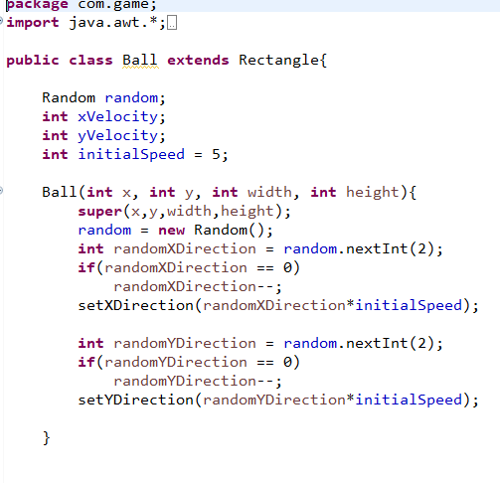

**Gamepanel.java:**Game panel extends Jpanel implements Runnable which contains the paddle Size ,movement,ball collision,graphics and Key adapter.

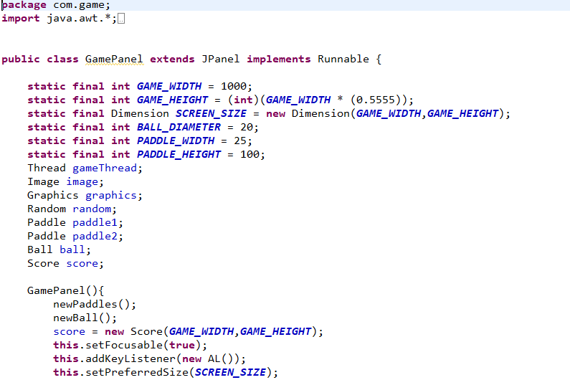**Ball and Paddle:**

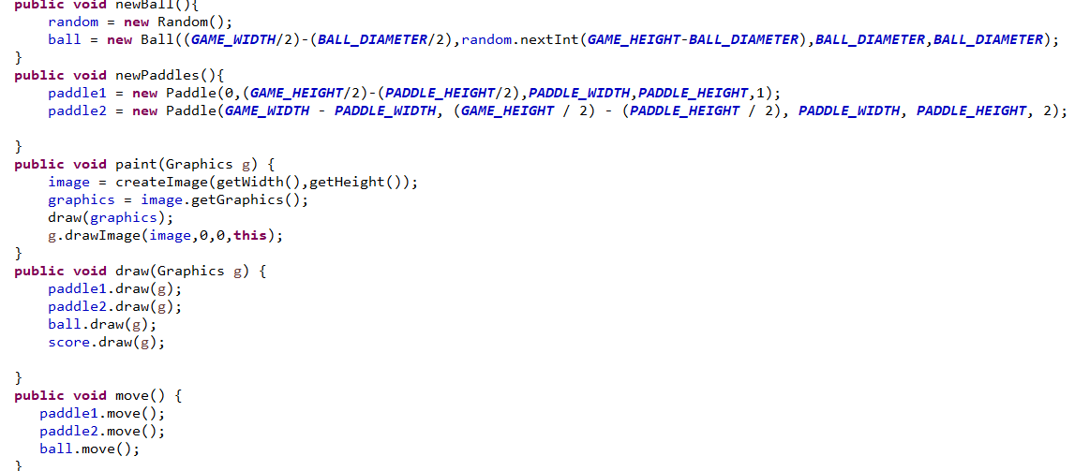

**Check Collison Method:**

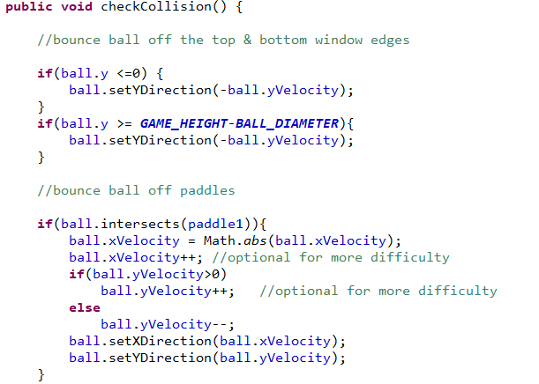

**Key Adapter:**

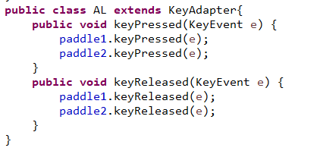

**Paddle.java:** In this paddle we declare the paddle speed and Key pressed and Key released for paddle control.

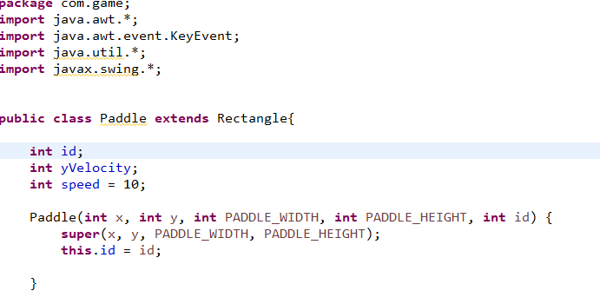

**Key Controls:**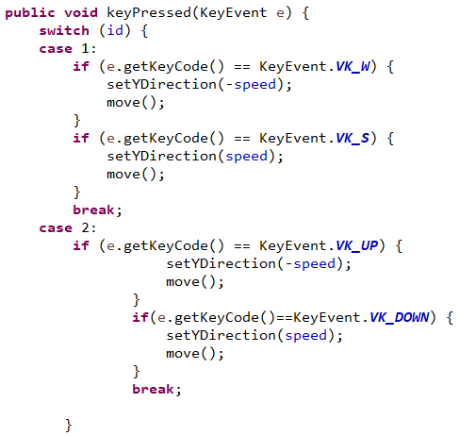

**Pong game.java:** Instance of the game frame is created and the game frame is going to hold a game panel (Window frame).

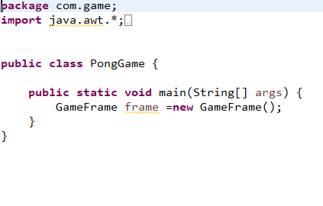

**Score.java:**Score class is extends to Recatange.The score class displays the score of both the players.

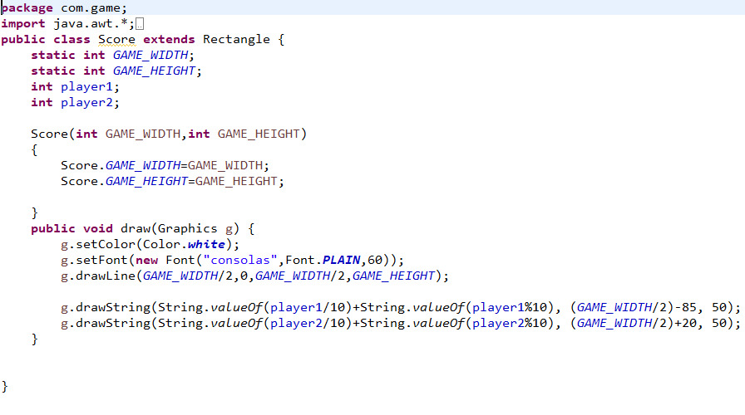

**Game frame.java:** **Game Frame:** Game frame extends to Jframe .It displays the main frame of the game including game title and game exit.

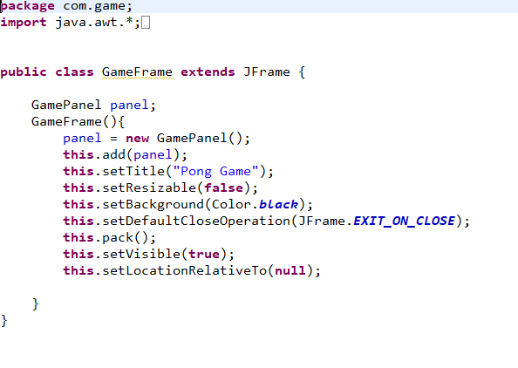

**DESCRIPTION OF PONG GAME:**

* The game can basically be described in three ways
* When game is started a red ball appears on the screen along with a 2 paddle.
* One can also see the SCORE at the top of the screen.
* Once the game starts the ball hits the screen’s side paddle and bounce.
* The main objective of a player is to control the movement of paddle to hit the ball.
* Speed of ball increases with the time.
* Score increases as long as the player continues to Hit the Ball.

**OUTPUT:**

**GAME PLAYING:**

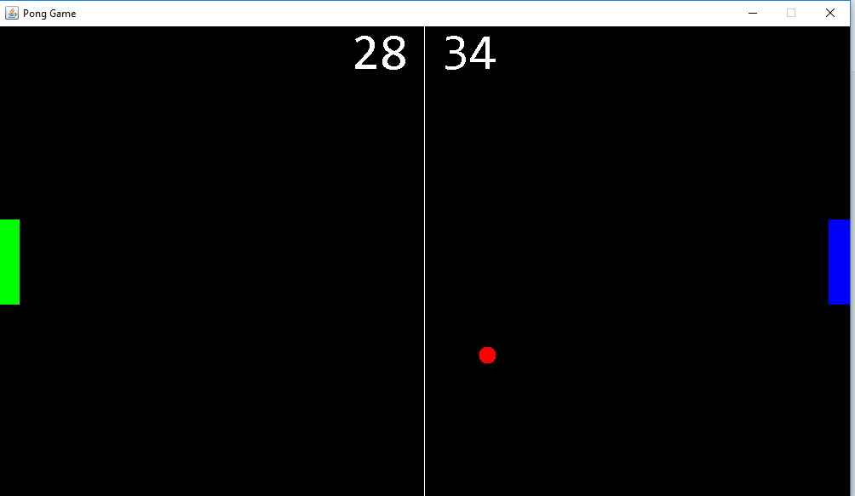

**SCORE DISPLAY:**

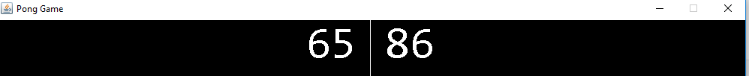

**Console output:**

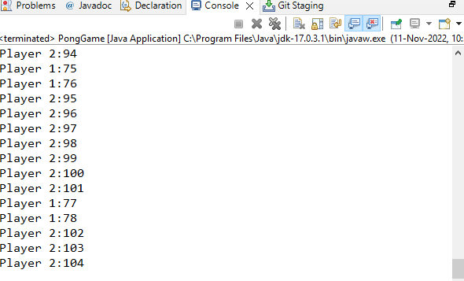

**CONCLUSION:**

As the level rises the game became more exciting,Game can be played in quick time .Since the game is developed using java it can be played in any system.